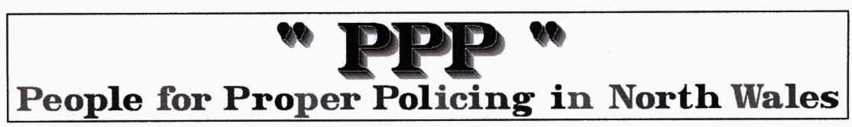
ANGER AT £18M BONUSES PAID TO POLICE
By Paul Jeeves Daily Express November 12th 2009

A CASH-strapped police force with a recruitment freeze has come under fire for pocketing “obscene” bonus payments of nearly £18million in the last five years. South Yorkshire officers were rewarded for what their superiors described as “competence-related” achievements. These include achieving good results, showing commitment to the job and developing good relations with the public.
Around 1,400 officers a year qualified for the payments of up to £5,000 a time.
Another £82,380 was paid to bobbies faced with difficult and unpleasant tasks during their working day. Senior officers were paid £193,206 in bonuses over the last five years.

South Yorkshire Chief Constable Med Hughes’s salary rose to £144,510 last month. With a bonus he would get another £21,600.

Doncaster councillor Tony Brown said: “Taxpayers will be absolutely outraged at these scandalous and obscene payments to policemen for simply doing their job.
The money would be better spent putting more bobbies on the beat to make the streets safer.”
Matthew Elliott, from, the TaxPayers’ Alliance, said: “While there may be some cases where the bonuses were merited, fighting crime and creating good community relations is the most basic function of the police force and we should not be giving out large cash payments for these duties.”

Yesterday, Mr Hughes said: “Every police force in the country does these schemes. It is part of the normal pay bill and misleading to call it a bonus system.”

The PPP comments …. More headline and shock horror outbursts from Press and politicians. We have been reporting on these abuses for years. The Police authorities, the self styled joke ‘watch dogs’ grant all these bonuses as they line their own pockets with our money. Med Hughes is again in the headlines for the all the wrong reasons. These bonuses are AGAINST ACPO policy, Ask ACPO president Hugh Orde to comment. All our previous articles on CC Hughes, ACPO and NWPF bonuses are on our site at the following links….

There used to be a sick joke in Industry that the ‘workers’ were paid to turn up but had to be paid bonuses to actually do anything …. seems an appropriate comment on this situation!

www.properpolicing.org.uk/articles/They%20are%20ALL%20making%20money%20from%20Speed%20cameras.pdf

www.properpolicing.org.uk/articles/ACPO%20comment%20on%20Chief%20Officer%20Bonuses.pdf

www.properpolicing.org.uk/articles/South%20Yorkshire%20police's%20unknown%20Speeders.doc

http://www.properpolicing.org.uk/articles/What%20does%20NWPF%20cost%20&%20why.pdf

